LAB 5: INTRODUCTION TO CSS

Objective(s) :
- To create HTML pages with style sheet.
- To implement different levels of style sheet.

INTRODUCTION
A style sheet is a set of instructions each of which tells a browser how to draw a particular element on a page. HTML documents are a collection of elements arranged in a hierarchy.

LEVELS OF STYLE SHEET
There are four ways to associate styles with your HTML document. Most commonly used
methods are inline CSS and External CSS.

- INLINE
<p style="text-indent: 10pt">indented paragraph</p>
- DOCUMENT
<head>
<style type="text/css" media="all">
Style Rules
............
</style>
</head>
- EXTERNAL
<head>
<link type="text/css" href="Style.css" rel="stylesheet" />
</head>
- IMPORTED CSS RULE
<head> <@import url("URL"); </head>

<head> @import "mystyle.css"; </head>

CSS RULE
A CSS comprises of style rules that are interpreted by the browser and then applied to
the corresponding elements in your document. A style rule is made of three parts: selector, property and its value. Declaration is shown below.
Selector
{ property_1 :value_1 ;
Property-2 :value_2;
Property_3 : value_3;
}

TYPES OF SELECTORS

- SIMPLE SELECTOR
H1 { property_1 : value_1;}  H1, h2 { Property-1 :value_1;  Property_2 : value_2; | H1 {  Background-color : green ;  Font-family : Times new Romen;  }

- UNIVERSAL SELECTOR
*{ Property-1 :value_1;  Property_2 : value_2;} | *{ Background-color : green ;  Font-family : Times new Romen;}

- DECENDANT SELECTORS
ul em {
Property-1 :value_1; Property_2 : value_2;}

- CLASS SELECTORS
.black {
color: #000000;
}
h1.black {
color: #000000;}
<h1 class=”black”> heading </h1>
<p class="black">
This para will be styled by the classes center and bold.</p>

- ID SELECTORS
h1#black {
color: #000000;
}

#black {
color: #000000;
}

- CHILD SELECTORS
body > p {
color: #000000;
}

- GROUPING SELECTORS (TYPE SELECTOR)
h1, h2, h3 {
color: #36C;
font-weight: normal;
letter-spacing: .4em;
margin-bottom: 1em;
text-transform: lowercase;
}

MULTIPLE STYLE RULES

h1 {
color: #36C;
font-weight: normal;
letter-spacing: .4em;
margin-bottom: 1em;
text-transform: lowercase;
}

CSS BACKGROUNDS
The background-color property is used to set the background color of an element.

- The background-image property is used to set the background image of an element.
- The background-repeat property is used to control the repetition of an image in the background.
- The background-position property is used to control the position of an image in the background.
- The background-attachment property is used to control the scrolling of an image in the background.
- The background property is used as a shorthand to specify a number of other background properties.
CSS FONTS
- The font-family property is used to change the face of a font.
- The font-style property is used to make a font italic or oblique.
- The font-variant property is used to create a small-caps effect.
- The font-weight property is used to increase or decrease how bold or light a font appears
- The font-size property is used to increase or decrease the size of a font.
- The font property is used as shorthand to specify a number of other font properties.

<html lang = "en">
<head>
<style type = "text/css">
p {
color : blue;
font-family:georgia,garamond,serif;
font-style:italic;
font-variant:small-caps;
font-weight:bold;
font-size:small;
font-size-adjust:0.61;
font-stretch:ultra-expanded; /* font:italic small-caps bold 15px georgia;*/
}
</style>
</head>
<title> css fonts </title>
<body>
<p>
A CSS comprises of style rules that are interpreted by the browser and then applied to
the corresponding elements in your document. A style rule is made of three parts:
</p>
</body>
</html>

CSS TEXT
- The color property is used to set the color of a text.
- The direction property is used to set the text direction.
- The letter-spacing property is used to add or subtract space between the letters that make up a word.
- The word-spacing property is used to add or subtract space between the words of a sentence.
- The text-indent property is used to indent the text of a paragraph.
- The text-align property is used to align the text of a document.
- The text-decoration property is used to underline, overline, and strikethrough text.
- The text-transform property is used to capitalize text or convert text to uppercase or lowercase letters.
- The white-space property is used to control the flow and formatting of text.
- The text-shadow property is used to set the text shadow around a text.

<html lang = "en">
<head>
<style type = "text/css">
p {
color : red;
direction:rtl;
letter-spacing:5px;
word-spacing:5px;
text-indent:1cm;
text-align:right;
text-transform:capitalize;
text-shadow:4px 4px 8px blue;
}
</style>
</head>
<title> css fonts </title>
<body>
<p>
A CSS comprises of style rules that are interpreted by the browser and then applied to
the corresponding elements in your document. A style rule is made of three parts:
</p>
</body>
</html>

CSS BORDERS
- The border-collapse specifies whether the browser should control the appearance of the adjacent borders that touch each other or whether each cell should maintain its style.
- The border-spacing specifies the width that should appear between table cells.
- The caption-side captions are presented in the <caption> element. By default, these are rendered above the table in the document. You use the caption-side property to control the placement of the table caption.
- The empty-cells specifies whether the border should be shown if a cell is empty.
- The table-layout allows browsers to speed up the layout of a table by using the first width properties it comes across for the rest of a column rather than having to load the whole table before rendering it.
<style type="text/css">
table.one {border-collapse:collapse;}
table.two {border-collapse:separate;}
td.a {
border-style:dotted;
border-width:3px;
border-color:#000000;
padding: 10px;
}
td.b {border-style:solid;
border-width:3px;
border-color:#333333;
padding:10px;
}
</style>

Exercise 1
(Use external level Style sheet)
Design a multiple webpages including html & CSS. Include all the CSS properties of text , border font etc. The following navigation tabs must be added:
- Home ( Give info about what your website is about)
- Information (Include the detailed information related to the particular technology)
- Gallery (Include images and Videos of technology)
- About (Give the information about your self)
Exercise 2
Write a CSS rule that makes all text 1.5 times larger than the base font of the system and colors the text red.
Exercise 3
Write a CSS rule that places a background image halfway down the page, tiling it horizontally.
The image should remain in place when the user scrolls up or down.
Exercise 4
Write a CSS rule that gives all h1 and h2 elements a padding of 0.5 ems, a dashed border style and a margin of 0.5 ems.
Exercise 5
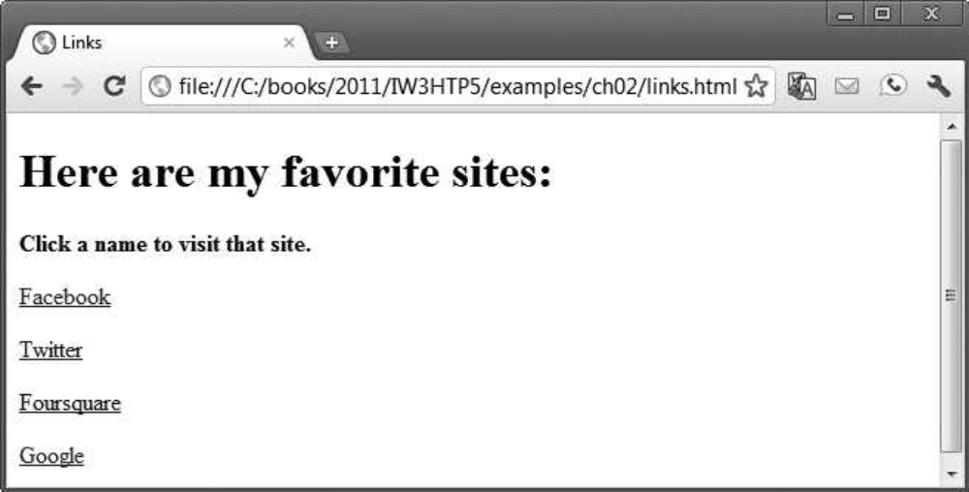
Add an embedded style sheet to the HTML5 document in the above figure..The style sheet should contain a rule that displays h1 elements in blue. In addition, create a rule that displays all links in
blue without underlining them. When the mouse hovers over a link, change the link’s background
color to yellow.
Exercise 6
Make a navigation button using a div with a link inside it. Give it a border, background, and text color, and make them change when the user hovers the mouse over the button. Use an external
style sheet.

